**FOR COMMENTS OF THREADS………………………………………………………**

**GALC INDEX**

**Link to sheet:** [**https://docs.google.com/spreadsheets/d/1NIx_WbjkXty5y07jh8fclyRkLWlS0tzGhkLdnadQ4TM/edit?usp=sharing**](https://docs.google.com/spreadsheets/d/1NIx_WbjkXty5y07jh8fclyRkLWlS0tzGhkLdnadQ4TM/edit?usp=sharing)

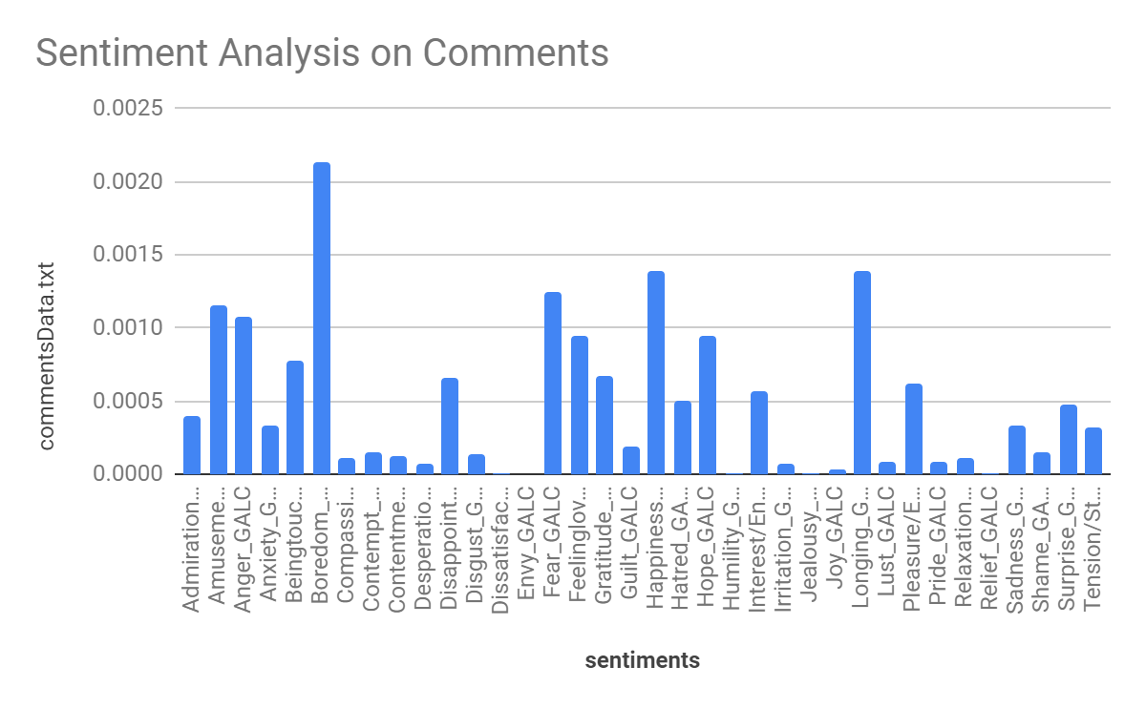

The top 5 sentiments are as follows: boredom was the most prominent sentiment shared by a majority of the comments in the thread. Happiness and Longing were close 2NDs, following fear, amusement, and anger.

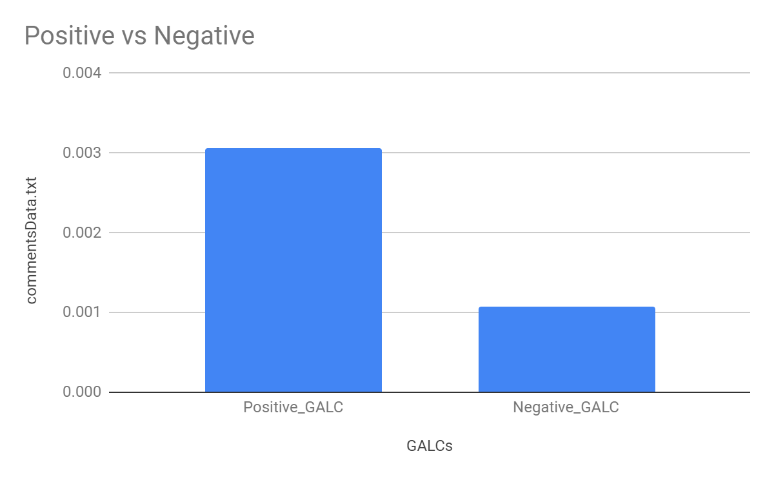

Ultimately, the positive comments outweighed the negative comments.

**Word Component**

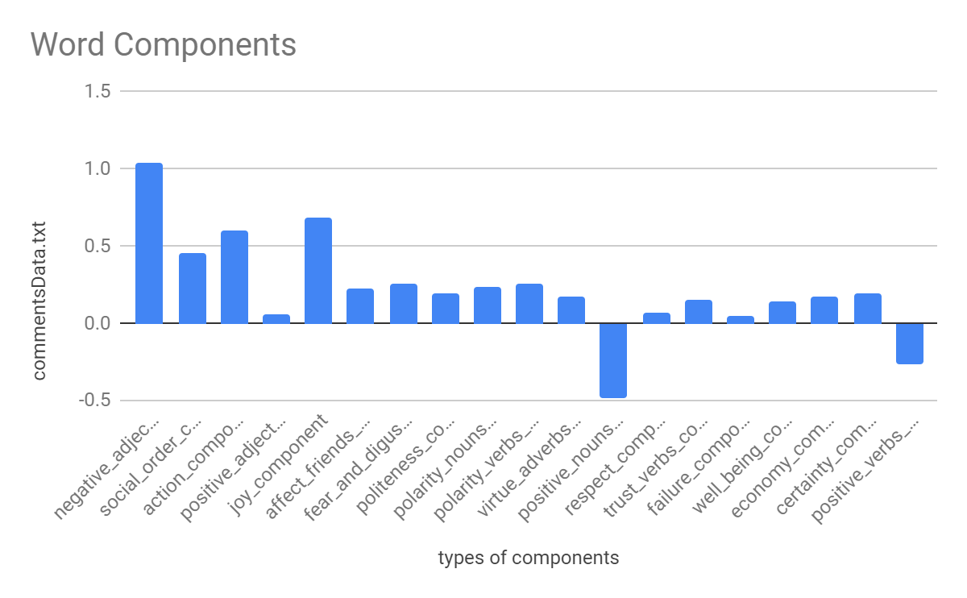

**TOP 3 Word Components:** There are noticeably more negative adjectives in the comments, followed by joy-related comments, action-related comments, and social order-related components.

**FOR POSTS THREADS……………....…………………………………………………**

**GALC INDEX**

**Link:** [**https://docs.google.com/spreadsheets/d/1TWSoDEjRplgLonQtgTfw9Tk1zNqI97KeOIcq8IsBp3M/edit?usp=sharing**](https://docs.google.com/spreadsheets/d/1TWSoDEjRplgLonQtgTfw9Tk1zNqI97KeOIcq8IsBp3M/edit?usp=sharing)

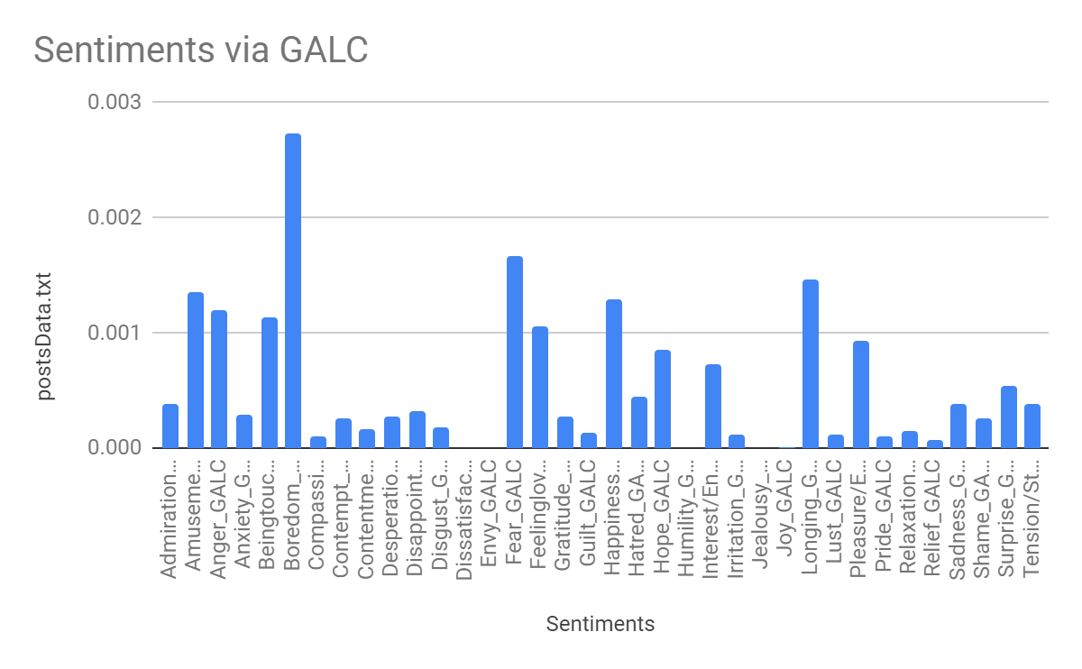

The top 5 sentiments are as follows: boredom was the most prominent sentiment shared by the posts. Fear being 2nd, following fear is Longing, Amusement, and Happiness. Not too different from the sentiment scores of the comments.

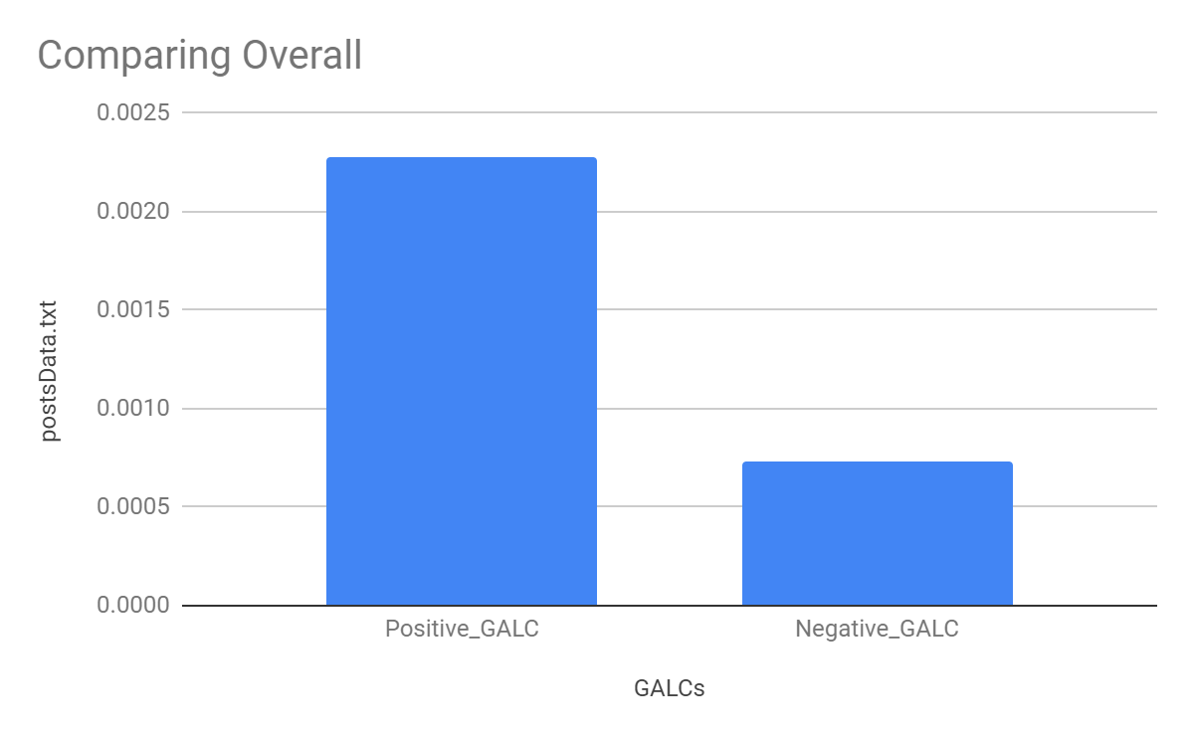

Overall, the positive sentiments of posts outweigh the negative ones as well.

**Word Component**

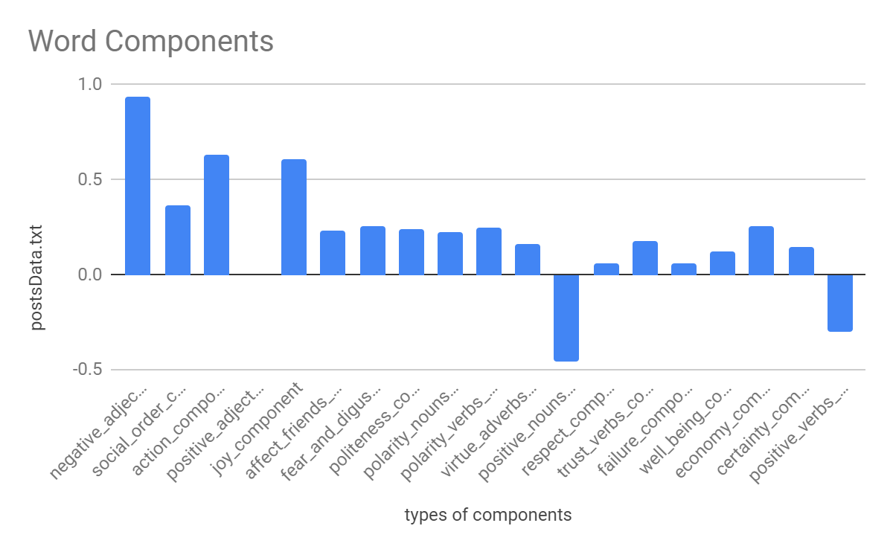

Negative adjective components are the most observed in the posts, Followed by action components and joy components.